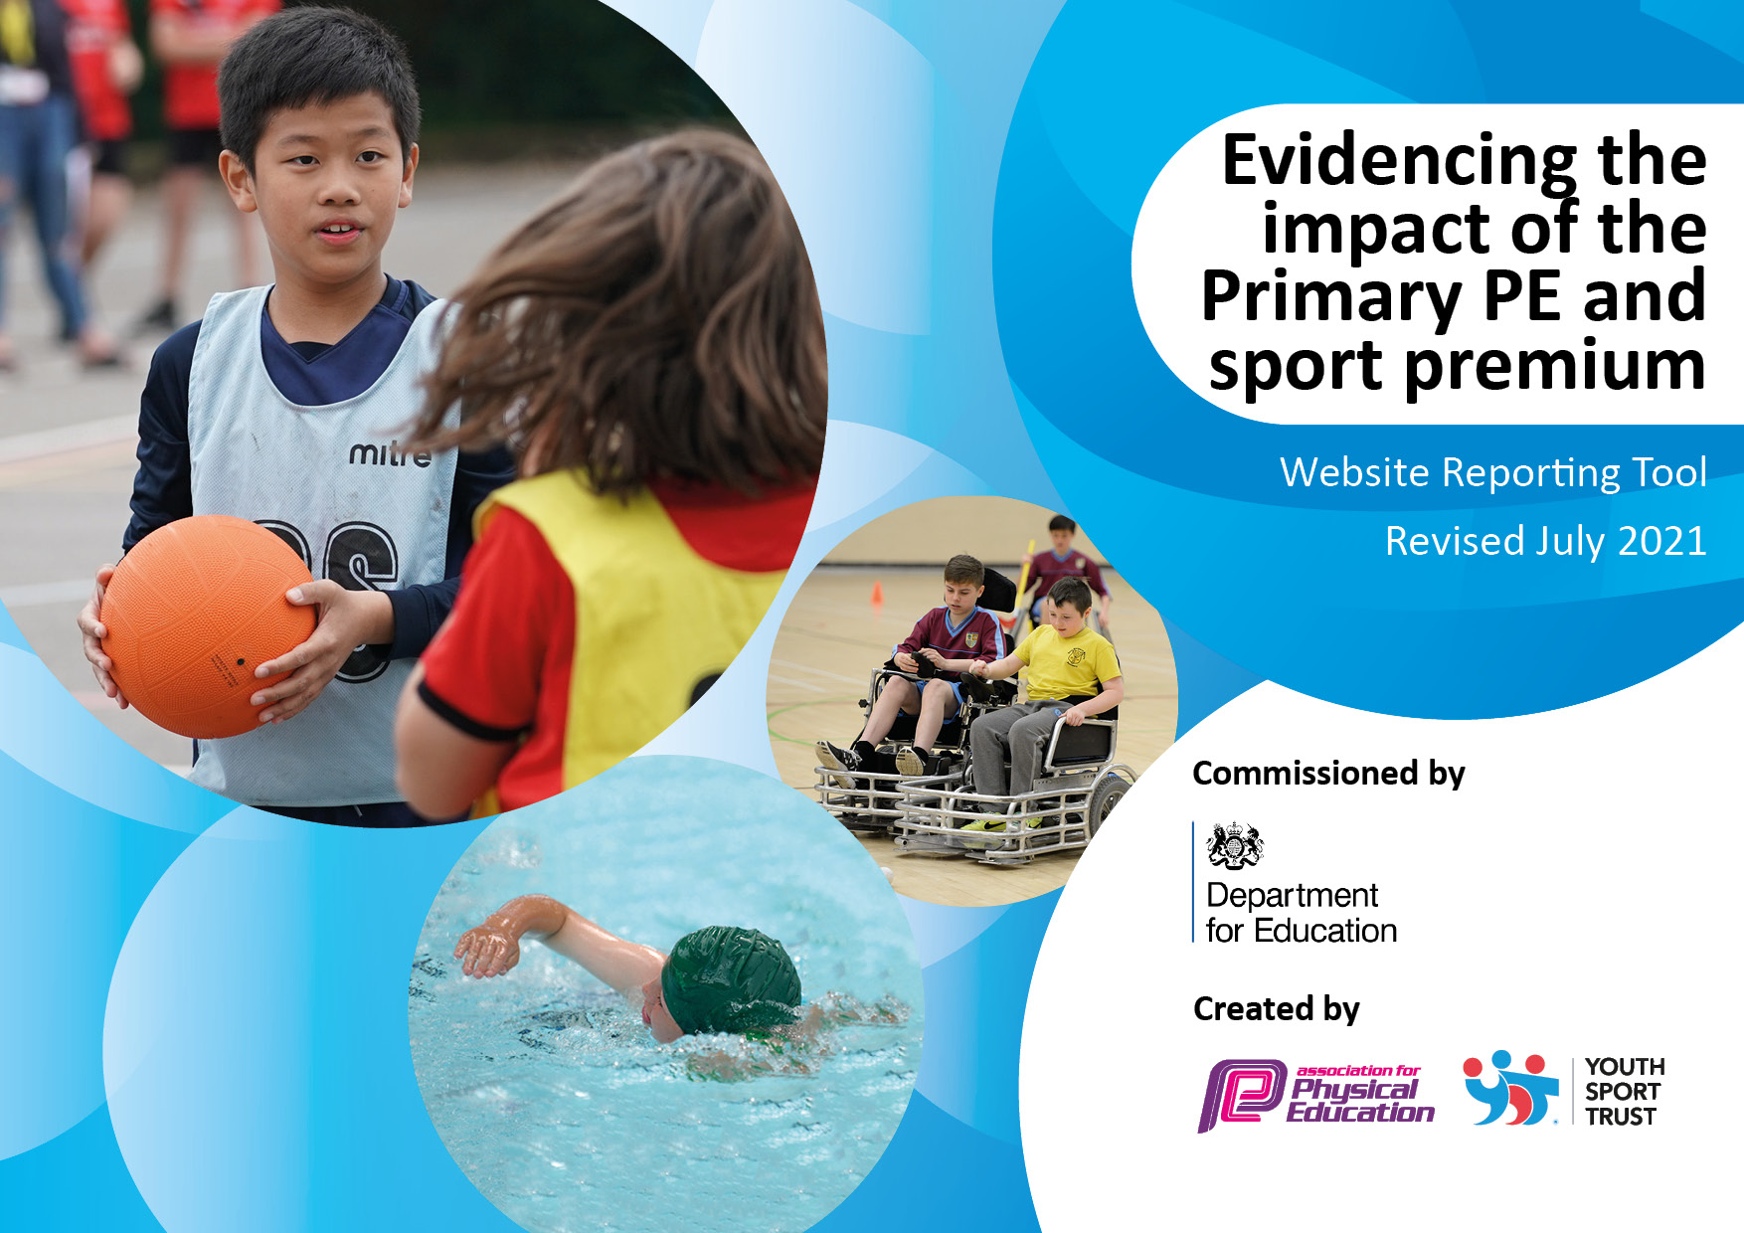

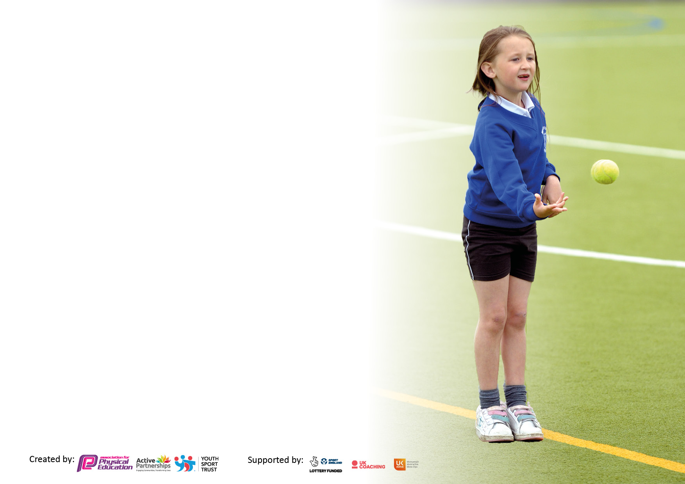

It is important that your grant is used effectively and based on school need. The [Education Inspection Framework](https://assets.publishing.service.gov.uk/government/uploads/system/uploads/attachment_data/file/843108/School_inspection_handbook_-_section_5.pdf) makes clear there will be a focus on **‘whether leaders and those responsible for governors all understand their respective roles and perform these in a way that enhances the effectiveness of the school’**.

Under the [Quality of Education](https://assets.publishing.service.gov.uk/government/uploads/system/uploads/attachment_data/file/843108/School_inspection_handbook_-_section_5.pdf) Ofsted inspectors consider:

**Intent** - Curriculum design, coverage and appropriateness

**Implementation** - Curriculum delivery, Teaching (pedagogy) and Assessment

**Impact** - Attainment and progress

To assist schools with common transferable language this template has been developed to utilise the same three headings which should make your plans easily transferable between working documents.

Schools must use the funding to make **additional and sustainable** improvements to the quality of Physical Education, School Sport and Physical Activity (PESSPA) they offer. This means that you should use the Primary PE and sport premium to:

* Develop or add to the PESSPA activities that your school already offer
* Build capacity and capability within the school to ensure that improvements made now will benefit pupils joining the school in future years
* The Primary PE and sport premium should not be used to fund capital spend projects; the school’s budget should fund these.

Pleasevisit[gov.uk](https://www.gov.uk/guidance/pe-and-sport-premium-for-primary-schools)fortherevisedDfEguidanceincludingthe5keyindicatorsacrosswhichschoolsshoulddemonstrate animprovement.Thisdocumentwillhelpyoutoreviewyourprovisionandtoreportyourspend.DfEencouragesschools to use this template as an effective way of meeting the reporting requirements of the Primary PE and sport premium.

We recommend you start by reflecting on the impact of current provision and reviewing the previous spend.

Schools are required to [publish details](https://www.gov.uk/guidance/what-maintained-schools-must-publish-online#pe-and-sport-premium-for-primary-schools) of how they spend this funding, including any under-spend from 2019/2020, as well as on the impact it has on pupils’ PE and sport participation and attainment. **All funding must be spent by 31st July 2022.**

We recommend regularly updating the table and publishing it on your website throughout the year. This evidences your ongoing self-evaluation of how you are using the funding to secure maximum, sustainable impact. Final copy must be posted on your website by the end of the academic year and no later than the 31st July 2021. To see an example of how to complete the table please click [HERE](http://www.afpe.org.uk/physical-education/wp-content/uploads/afPE-Example-Template-Indicator-2018-Final.pdf).



**Details with regard to funding**

Please complete the table below.

|  |  |
| --- | --- |
| Total amount carried over from 2021/22? | £0 |
| Total amount allocated for 2021/22 | £17,500 |
| How much (if any) do you intend to carry over from this total fund into 2022/23? | £0 |
| Total amount allocated for 2022/23 | £17,500 |
| Total amount of funding for 2022/23. To be spent and reported on by 31st July 2023. | £17,500 |

**Swimming Data**

Please report on your Swimming Data below.

|  |  |
| --- | --- |
| Meeting national curriculum requirements for swimming and water safety.  N.B. Complete this section to your best ability. For example you might have practised safe self-rescue techniques on dry land which you can then transfer to the pool when school swimming restarts.  **Due to exceptional circumstances priority should be given to ensuring that pupils can perform safe self rescue even if they do not fully meet the first two requirements of the NC programme of study** | 27% |
| What percentage of your current Year 6 cohort swim competently, confidently and proficiently over a distance of at least 25 metres?  **N.B.** Even though your pupils may swim in another year please report on their attainment on leaving primary school at the end of the summer term 2020.  Please see note above | 27% |
| What percentage of your current Year 6 cohort use a range of strokes effectively [for example, front crawl, backstroke and breaststroke]?  Please see note above | 27% |
| **What percentage of your current Year 6 cohort perform safe self-rescue in different water-based situations?** | 17% |
| Schools can choose to use the Primary PE and sport premium to provide additional provision for swimming but this must be for activity **over and above** the national curriculum requirements. Have you used it in this way? | Yes |

**Action Plan and Budget Tracking**

Capture your intended annual spend against the 5 key indicators. Clarify the success criteria and evidence of impact that you intend to measure to evaluate for pupils today and for the future.

|  |  |  |  |  |
| --- | --- | --- | --- | --- |
| **Academic Year:** 2022/23 | **Total fund allocated: £17,500** | **Date Updated: 11.7.2022** | |  |
| **Key indicator 1:** The engagement of all pupils in regular physical activity – Chief Medical Officers guidelines recommend that primary school pupils undertake at least 30 minutes of physical activity a day in school | | | | Percentage of total allocation: |
| 13% |
| **Intent** | **Implementation** | | **Impact** |  |
| Your school focus should be clear what you want the pupils to know and be able to do and about  what they need to learn and to  consolidate through practice: | Make sure your actions to achieve are linked to your intentions: | Funding allocated: | Evidence of impact: what do pupils now know and what can they now do? What has changed?: | Sustainability and suggested next steps: |
| Provide support for targeted group of inactive children to engage in physical activities. | * Invite children who are inactive to additional clubs * Lunchtime fitness session for target children * Intervention group for SEND and reception children to improve gross motor skills | £2,330 | * Inactive children are given more opportunities to engage in physical activities. * Inactive children are more motivated to participate in PE and enjoy being physically active | Continue to monitor and review the children who participate in group |
| Daily mile completed daily throughout school | * Daily mile reintroduced to ensure children are physically active daily * Sessions are timetabled to ensure physical activity is prioritised daily | £0 | * Children become more physically active * Children enjoy participating in regular activity | Staff to continue to promote daily mile and ensure it is completed daily for maximum benefit |
| A variety of after school clubs provided daily | * Target inactive children * Cater to both key stages * Provide a range of sporting activities | See costing below | * Children become more physically active * Children enjoy participating in regular activity | Fit 2 Play staff to carry out after school clubs  Pupil feedback about sporting opportunities on offer |
| **Key indicator 2:** The profile of PESSPA being raised across the school as a tool for whole school improvement | | | | Percentage of total allocation: |
| 3% |
| **Intent** | **Implementation** | | **Impact** |  |
| Your school focus should be clear what you want the pupils to know and be able to do and about  what they need to learn and to  consolidate through practice: | Make sure your actions to achieve are linked to your intentions: | Funding allocated: | Evidence of impact: what do pupils now know and what can they now do? What has changed?: | Sustainability and suggested next steps: |
| PE equipment purchased so there is enough equipment for children to fully participate and enjoy PE lessons | * Carry out a stock take of the PE store room * Order equipment needed to teach PE effectively | £300 | Pupils are able to participate in lessons using correct equipment | Regular stock checks carried out to ensure equipment is maintained and plentiful for PE lessons |
| Play leaders reintroduced at playtimes | * Train Y6 pupils to be play leaders to encourage all children in school to join in sporting activities * Buy new equipment | £200 | Children active at lunchtimes  Children enjoying sporting opportunities  Y6 developing leadership skills | Buy equipment  Rotate activities to keep children interested  Get regular feedback from children about their opinions on play leaders |
| PE awards | * KS1 and KS2 class of the week given PE certificate during celebration worship for attitude and behaviour | £0 | Children improve behaviour in PE lessons  Children keen to work as a class in order to win award | Recognise and promote positive PE behaviours during the week |

|  |  |  |  |  |
| --- | --- | --- | --- | --- |
| **Key indicator 3:** Increased confidence, knowledge and skills of all staff in teaching PE and sport | | | | Percentage of total allocation: |
| 52% |
| **Intent** | **Implementation** | | **Impact** |  |
| Your school focus should be clear | Make sure your actions to | Funding | Evidence of impact: what do | Sustainability and suggested |
| what you want the pupils to know | achieve are linked to your | allocated: | pupils now know and what | next steps: |
| and be able to do and about | intentions: |  | can they now do? What has |  |
| what they need to learn and to |  |  | changed?: |  |
| consolidate through practice: |  |  |  |  |
| Use sports coaches (Fit 4 Play) to deliver PE lessons in order to develop teacher’s subject knowledge and increase teacher confidence level. | * Teachers to observe delivery of sport coach lessons and develop practice. * Teachers to deliver own lessons based of sports coach lessons and evaluate the impact of their teaching. | £9,120 | * Children receive quality first teaching in P.E. * Teacher’s delivery of P.E lessons is enhanced. * Teacher’s more able to adapt and progress their delivery of P.E lessons | Staff regularly observe sports coaches and put new skills into practise in order to improve the teaching of PE |
| **Key indicator 4:** Broader experience of a range of sports and activities offered to all pupils | | | | Percentage of total allocation: |
| 32% |
| **Intent** | **Implementation** | | **Impact** |  |
| Your school focus should be clear | Make sure your actions to | Funding | Evidence of impact: what do | Sustainability and suggested |
| what you want the pupils to know | achieve are linked to your | allocated: | pupils now know and what | next steps: |
| and be able to do and about | intentions: |  | can they now do? What has |  |
| what they need to learn and to |  |  | changed?: |  |
| consolidate through practice: |  |  |  |  |
| Group intervention to improve mental health of pupils | Small group intervention session using punchbag and/or trampoline to release any negative emotions | £150 | * Children feel able happier and settled in school * Children able to channel their emotions in a safe place | Continue to monitor and review the children who participate in group |
| Range of after school clubs provided such as football, gymnastics and netball to offer children a range of sporting opportunities | * Regular after school clubs provided for whole school * Groups changed termly to allow variety of children to participate | £2,420 | * Children are more physically active * Children experience a wider range of sporting opportunities * Children able to socialise with peers while taking part in clubs | Continue to monitor and review the children who participate in group  After school clubs are timetabled to ensure consistency |
| Residential trip for Y5 funded for PP children | * Fund residential trip for all PP children to ensure equal opportunities for all | £1000 | * All children able to participate in residential trip * Children are able to be physically active while learning new skills |  |
| Y6 children who did not achieve NC level in swimming in Y3 will continue to practise during Y6 | * Identify children who did not achieve the 25m award in Y3 * During Spring and Summer term, send Y6 children to swimming lessons to be able to meet the NC standard before leaving primary school | £1,980 | * Y6 children will leave school being able to confidently swim at least 25m unaided * Children become more confident in water * Children are more physically active while learning new skills | Monitor children when swimming using Swimphony to see which children have met the NC level |
| Cricket sports coach to lead cricket sessions to whole school for 6 weeks | * Each class receives 1 hour of cricket one day a week for 6 weeks | £0 | * Children benefit from having a professional coach teaching them cricket * Children try a new sport * Promotion of sporting activities | All staff encouraged to take part in coaching sessions for CPD |
| Regularly participate in School Games Activities | * Each term, take part in a range of activities, in both key stages at participation level | £0 | * Children exposed to a range of sporting opportunities * Pupil Premium and SEND children included | All staff to involved in choosing and participating in activities.  Each teacher encouraged to go to an event each term |

|  |  |  |  |  |
| --- | --- | --- | --- | --- |
| **Key indicator 5:** Increased participation in competitive sport | | | | Percentage of total allocation: |
| 0% |
| **Intent** | **Implementation** | | **Impact** |  |
| Your school focus should be clear | Make sure your actions to | Funding | Evidence of impact: what do | Sustainability and suggested |
| what you want the pupils to know | achieve are linked to your | allocated: | pupils now know and what | next steps: |
| and be able to do and about | intentions: |  | can they now do? What has |  |
| what they need to learn and to |  |  | changed?: |  |
| consolidate through practice: |  |  |  |  |
| Begin to create after school football/netball teams and practise regularly | * Create a team and begin training regularly * Contact local schools of a similar ability and arrange friendly games for practise | £0 | * Children more physically active * Raise children’s confidence levels when representing their school and playing against others * Improvement in level of sportsmanship throughout school | When confident as a school team, begin joining local tournaments and competitions |
| Participate in competitive School Games activities | * Regularly take part in competitive activities in a range of sports | £0 | * Children have experience in competitive activities * Children encouraged to represent our school and show good sportsmanship | Staff encouraged to be involved  Staff keep up to date with the activities that are on offer from School Games |

|  |  |
| --- | --- |
| Signed off by | |
| Head Teacher: |  |
| Date: |  |
| Subject Leader: | C.Cash |
| Date: | 11.7.22 |
| Governor: |  |
| Date: |  |