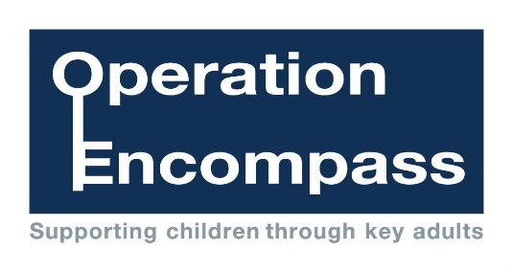

**Wigan Encompass**

The purpose of Wigan Encompass is to safeguard and support children and young people who have been involved in or witness to a domestic abuse incident. Domestic abuse impacts on children in a number of ways. Children are at increased risk of physical injury during an incident, either by accident or because they attempt to intervene. Even when not directly injured, children are greatly distressed by witnessing the physical and emotional suffering of a parent.

Encompass has been created to address this situation. It is the implementation of key partnership working between the police and schools. The aim of sharing information with local schools is to allow ‘Key Adults’ the opportunity of engaging with the child and to provide access to support that allows them to remain in a safe but secure familiar environment.

Following the report of an incident of domestic abuse, by 9.00am on the next school day the school’s Key Adult will be informed that the child or young person has been involved in a domestic incident. This knowledge, given to schools through Operation Encompass, allows the provision of immediate early intervention through silent or overt support dependent upon the needs and wishes of the child.

The purpose and procedures in Operation Encompass have been shared with all parents and governors, is detailed as part of the school’s Safeguarding Policy and published on our school website.

At St Pauls our Key Adult is Mrs Fiona Turner.