A Guide for Parents 

The New National Curriculum

In September 2013, the Government announced plans to overhaul the National Curriculum and in 2014 the primary school curriculum was up-dated with many changes. So why was a change needed and how has our school reacted to the change so far?

**Why the big curriculum change?**

The Government’s aim is to raise standards, particularly as the UK is slipping down international pupil assessment league tables. Inspired by what is taught in the world’s most successful school systems, including Hong Kong, Singapore and Finland, as well as in the best UK schools, the new National Curriculum is designed to produce productive, creative and well educated students who will be able to compete in the international market.

Although the new curriculum is intended to be more challenging, the content is actually slimmer than the current curriculum, focusing on essential core subject knowledge and skills.



**What are the main changes?**

The table below **summarises** the main changes in the core subjects covered by the National Curriculum. It is evident that the level of challenge is much higher now.

**Changes in the Mathematics Curriculum**

|  |  |
| --- | --- |
| Key changes at KS1 | |
| Year 1 | **As part of ‘number’ in the post-2014 Curriculum, pupils should be taught to:**   * Familiarise themselves with – and use – a greater amount of numbers sooner. For example, they will be required to count to and across 100 and count, read and write numbers to 100 in numerals. The pre-2014 requirement was for pupils to reach 100 by the end of KS1 * Use addition and subtraction symbols * Solve one-step multiplication and division problems * Recognise, find and name the fractions one-half and one-quarter. Fractions featured in KS2 of the pre-2014 curriculum * As part of ‘measurement’, pupils will no longer be required to use non-standard units of measurements (for example, a straw, or wooden cubes) as part of the statutory curriculum |
| Year 2* | **As part of ‘number’ in the post-2014 curriculum, pupils should be taught to:**   * Count in steps of 2, 3 and 5 from 0, and in tens from any number forward and backwards * Use the symbols < and > * Perform mental calculations with a wider range of numbers. Pupils will also derive and use facts for numbers up to 100 * Use multiplication and division facts for the 2, 5 and 10 multiplication tables * Recognise and write fractions 1/3, 1/4, 2/4 and 3/4 of a length, shape, set of objects or quantity   **As part of ‘measurement’, pupils should be taught to:**   * Use degrees Celsius, and recognise and use monetary symbols (£ and p) * Tell and write the time to five minutes   **As part of ‘statistics’, pupils should be taught to:**   * Interpret and construct simple pictograms, tally charts, block diagrams and tables * Ask and answer simple questions by counting the number of objects in each category and sorting the categories by quantity * Ask and answer questions about totalling and comparing categorical data |
| Key changes at lower KS2 | |
| Year 3 | **In the post-2014 Curriculum, as part of ‘number’, pupils should be taught to:**   * Count from 0 in multiples of 4, 8, 50 and 100 * Compare and order numbers up to 1,000 * Continue work with estimation * Read and write numbers up to 1,000 in numerals and words * Add and subtract numbers mentally, including three-digit numbers with ones, tens and hundreds * Use inverse calculations to check the original calculations are correct * Recall multiplication and division facts for 3, 4 and 8 multiplication tables * Recognise, find, write and use a wide range of fractions   **In ‘measurement’, pupils should be taught to:**   * Add and subtract amounts of money to give change using both pounds and pence * Tell and write the time from an analogue clock, including using Roman numerals from I to XII, and using 12- and 24-hour clocks * Compare the duration of events   **In ‘statistics’, pupils should be taught to:**   * Interpret and present data using bar charts, pictograms and tables (previously ‘data handling’) * Solve one- and two-step questions using information presented in scaled bar charts and pictograms and tables |
| Year 4 | **As part of ‘number’, pupils should be taught to:**   * Count in multiples of 6, 7, 9, 25 and 1,000 * Count backwards from zero (including negative numbers) * Read Roman numerals to 100 (I to C) * Recall multiplication and division facts for tables up to 12 x 12 * Extend and develop work with increasingly complex fractions   **As part of ‘measurement’, pupils should be taught to:**   * Read, write and convert time between analogue and digital clocks * Solve problems involving converting from hours to minutes; minutes to seconds; years to months; weeks to days * Estimate, compare and calculate different measures, including money in pounds and pence |
| **Key changes at upper KS2** | |
| Year 5 | **The post-2014 Curriculum says pupils should be taught to:**   * Read, write, order and compare numbers to at least 1,000,000 * Count forwards or backwards in steps of powers of 10 for any given number up to 1,000,000 * Round any number up to 1,000,000 to the nearest 10, 100, 1000, 10,000 and 100,000 * Read Roman numerals to 1,000 (I to M), and recognise years written in Roman numerals * Add and subtract numbers with more than four digits (including using formal written methods) * Recognise and use cube numbers (including the notation for cubed) * Establish whether a number up to 100 is prime, and recall prime numbers up to 19 |
| Year 6 | **As part of ‘number’, pupils should be taught to:**   * Read, write, order and compare numbers up to 10,000,000 and determine the value of each digit * Perform mental calculations, including mixed operations and large numbers * Calculate decimal fraction equivalents * Add and subtract fractions with different denominators and mixed numbers, using the concept of equivalent fractions * Multiply simple pairs of proper fractions, writing the answer in its simplest form (for example, ¼ x ½ = 1/8) * Divide proper fractions by whole numbers (for example, 1/3 ÷ 2 = 1/6) * Associate a fraction with division and calculate decimal fraction equivalents for a simple fraction * Multiply one-digit numbers with up to two decimal places by whole numbers * Use written division methods in cases where the answer has up to two decimal places   **As part of ‘ratio and proportion’, pupils should be taught to:**   * Solve problems involving relative sizes of two quantities where missing values can be found by using integer multiplication and division facts * Solve problems involving calculation of percentages and the use of percentages for comparison * Solve problems involving similar shapes where the scale factor is known or can be found   **As part of ‘algebra’, pupils should be taught to:**   * Use simple formulae * Express mathematical problems algebraically   **As part of ‘measurement’, pupils should be taught to**:   * Convert between imperial and metric units * Recognise when it is possible to use formulae for area and volume of shapes * Calculate the area of parallelograms and triangles * Calculate, estimate and compare volume of cubes and cuboids using standard units   **As part of ‘statistics’, pupils should be taught to:**   * Calculate and interpret the mean as an average |

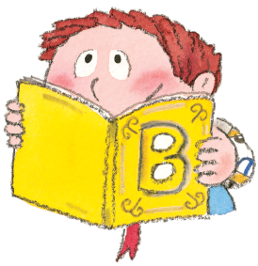

**Changes to the English National Curriculum**

|  |  |
| --- | --- |
| Key changes at KS1 and KS2 | |
| KS1 | **In reading, the post-2014 curriculum will require:**   * Greater emphasis on the role of synthetic phonics as the recommended strategy for teaching * Increased focus on reading for pleasure, and not simply reading for information * Greater emphasis on reading poetry and fiction * Greater emphasis on the role of discussion during reading activities * Pupils to ask, and answer, questions about a text (year 2 only) * Pupils to read whole texts, and not just extracts (year 2 only)   **In writing, the post-2014 curriculum will require:**   * The introduction of ‘common exception words’ (words with irregular spelling) * An emphasis on the role of spelling and, specifically, being able to spell the 40+ phonemes ( sounds) and days of the week * Pupils to write passages dictated by the teacher   **In handwriting, the curriculum will require:**   * Specific teaching to meet the needs of left-handed pupils * Pupils to learn to write numbers 1 to 9 * The requirement to identify correlations between handwriting ‘families’ * ‘Frequent and discrete’, direct teaching * More directive compositional strategies * Pupils to learn to use horizontal and diagonal strokes to join letters (Year 2 only) * Pupils to develop ‘stamina’ for writing by writing in a range of styles, including poetry (Year 2 only) |
| KS2 | **In reading, the curriculum will require:**   * Discussion of fiction, poetry, plays, non-fiction and reference books or textbooks * The preparation of poems and play scripts to read out loud * The need to recognise different forms of poetry * An emphasis on close textual reading and understanding, including literacy and linguistic devices, and making inferences about a text (reading beyond the text and suggesting reasons and opinions) * The need to increase familiarity with a wide range of books * The need to read whole texts * Less reference to drama * A shift from word reading to reading comprehension * Greater emphasis on reading for pleasure * A focus on applying own knowledge to digest new words and comprehend texts * Pupils to make comparisons between texts   **In writing, the curriculum will require:**   * An increased focus on developing and improving handwriting * A greater number of specific grammatical structures with which pupils will become familiar * An increased focus on editing and re-drafting work |

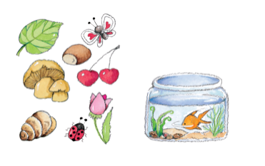

**Changes to the Science Curriculum**

|  |  |
| --- | --- |
| Key changes at KS1 | |
| Year 1 | **As part of ‘plants’, pupils should be taught to:**   * Identify and name a variety of common wild and garden plants, including deciduous and evergreen trees * Identify and describe the basic structure of a variety of common flowering plants, including trees   **As part of ‘animals, including humans’, pupils should be taught to:**   * Identify and name a variety of common animals that are birds, fish, amphibians, reptiles and mammals * Identify and name a variety of common animals that are carnivores, herbivores and omnivores   **The post-2014 curriculum now specifies which body parts should be taught in year 1, although this is non-statutory.**  **A new topic entitled ‘seasonal changes’ has been added. Pupils should be taught to:**   * Observe changes across the four seasons * Observe and describe weather associated with the seasons and how day length varies |
| Year 2 | **The post-2014 Curriculum**  contains a topic entitled ‘living things and their habitats’, in which pupils will learn about habitats and micro-habitats  **As part of ‘uses of everyday materials’, pupils should be taught to:**   * Compare how things move on different surfaces |
| Key changes at KS2 SCIENCE | |
| Year 3 | **As part of ‘rocks’, pupils should be taught to:**   * Compare and group together different kinds of rocks on the basis of their appearance and simple physical properties * Describe in simple terms how fossils are formed when things that have lived are trapped within rock * Recognise that soils are made from rocks and organic matter |
| Year 4 | **As part of ‘animals, including humans’, pupils should be taught to:**   * Describe the simple functions of basic parts of digestive system |
| Year 5 | **As part of ‘working scientifically’, pupils should be taught to:**   * Create models to describe scientific ideas   As part of ‘living things and their habitats’, pupils should be taught to:   * Describe the differences in the life cycles of mammals, amphibians, insects and birds * Describe the life processes of reproduction in some plants and animals |
| Year 6 | **A topic called ‘evolution and inheritance’ is introduced. In this topic, pupils should be taught to:**   * Recognise that living things have changed over time and that fossils provide information about living things that inhabited the Earth millions of years ago * Recognise that living things produce offspring of the same kind, but normally offspring vary and are not identical to their parents * Identify how animals and plants are adapted to suit their environment in different ways and that adaptation may lead to evolution   **As part of ‘electricity’, pupils will:**   * Associate the brightness of a lamp or the volume of a buzzer with the number and voltage of cells used in the circuit |

**Changes to Foundation Subjects**

|  |  |
| --- | --- |
| **Design & technology** | * Afforded **greater importance under the new curriculum**, setting children on the path to becoming the designers and engineers of the future * More sophisticated **use of design equipment** such as electronics and robotics * In KS2, children will learn about how key events and individuals in design and technology have shaped the world |
| **ICT** | * Computing replaces Information and Communication Technology (ICT), with a **greater focus on programming rather than on operating programs** * From age five, [children will learn to write and test simple programs, and to organise, store and retrieve data](http://www.theschoolrun.com/primary-school-coding-explained-for-parents) * From seven, they will be taught to understand computer networks, including the internet * Internet safety – currently only taught from 11-16 – will now be taught in primary schools |
| **Languages** | * A Foreign Language is now statutory at KS2. Children will be expected to master basic grammar and accurate pronunciation and to converse, present, read and write in the language |
| **Physical Education** | * Very little difference. However, the requirements for swimming have changed and are more challenging. Now pupils are expected to be able to swim 50-100 metres by the end of Year Six, using different strokes and breathing techniques. |
| **Geography and History** | * There are some changes to the topics to be taught in locational geography e.g. at KS1 pupils need to know about the capital cities and countries of the United Kingdom and be able to identify the seven continents and five oceans of the world. * Enquiry, skills and fieldwork in both Geography and History continue to be important and chronology in History is further developed with new topics introduced e.g. changes in Britain from the Stone Age to the Iron Age |

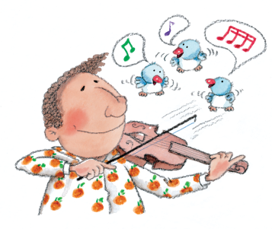The curriculum for Music and Art and Design remains largely unchanged.

Our Religious Education Curriculum is based on the Diocese Scheme and is monitored under a separate Inspection Framework, SIAMS.

**Removal of Levels of Attainment**

Under the New National Curriculum, levels as a measure of Attainment have been removed.

**What will happen instead of levels?**

The Government expects all schools to develop their own systems for assessment and tracking pupil progress, which will ensure that all pupils make good progress. We have invested in the Classroom Monitor System.

There will still be Statutory Tests at the end of each Key Stage and those at the end of Year Six will be externally marked, as at present. The first tests on the New National Curriculum will take place in summer 2016. The higher standards of the New National Curriculum will be tested at this point. Instead of levels, pupils will be awarded a scaled score.

**What are the challenges for our pupils?**

The curriculum for each year group is significantly more challenging than ever before. This means that:

* **Pupils who have previously been working above National Expectations may now be judged as meeting the expectation**
* **Pupils who have previously been working in line with National Expectations may now be judged as not yet met the new National Expectation**

Over time, pupils will need to make greater progress than ever before so that by the end of the Key Stage they meet the increased expectations. The minimum National expectation against which the performance of schools will be judged is that at least 85% of pupils should meet the standard.

**What are the challenges for parents and carers?**

We ask parents and carers to understand the challenges which are presented by the New National Curriculum and to continue to work with us in supporting their children with home learning.

It is important that parents fully understand the progress made by their children and how they have achieved against the New National Standards, so we will amend our end of year reports. We aim to make them straight forward, easy to understand, providing a clear picture of how each child is performing and celebrating their achievements. Your child’s next steps in learning will be taken from the New National Curriculum and identify what your child needs to do next to improve in English and Maths.

***It is anticipated that for pupils who were working at Level 2b (average) at the end of Year Two it will be unlikely that they will have met the National Expectation at the end of Year Three, (because of the increased level of challenge) unless progress across Year Three has been exceptional. The challenge is to ensure that consistently good progress over the next few years, cumulatively results in overall higher standards by the end of the Key Stage.***

***As a school we will continue to work with you to achieve this goal.***

**How has St. Paul’s C.E Primary responded to the challenges of the New National Curriculum?**

In preparation for the changes we;

* Evaluated our own curriculum to identify strengths and to highlight any gaps.
* Purchased new Maths plans from Lancashire to support teaching and learning
* Purchased resources and developed English planning (Grammar, Punctuation and handwriting)
* Provided training for our Subject Leaders in all areas of the new curriculum
* Held staff meetings to ensure all staff are fully informed about the new curriculum and assessment
* Briefed governors to ensure all are fully informed about the new curriculum and assessment
* Worked with other schools in our WOWS Learning Network to develop understanding of the new National Curriculum
* Produced a new Visual Maths Calculation Policy with our WOWS Network.
* Purchased Classroom Monitor as our assessment tool for all subjects and undertaken extensive training
* Re-designed our assessment and recording procedures

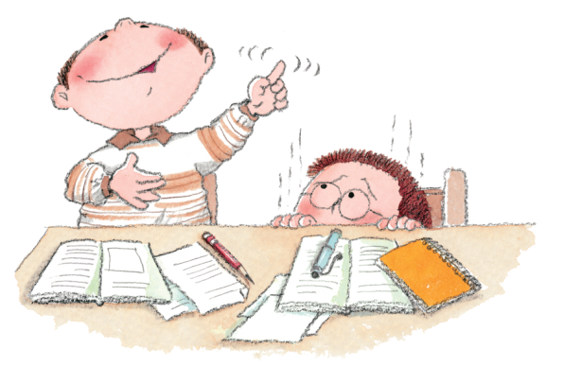

Many thanks to St. Aidan’s Catholic School for their kind support in sharing the original booklet.